Databases 2 Claims Assignment

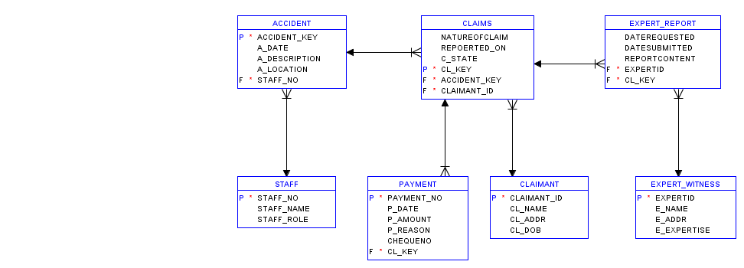

# Staff

Staff has staff number as a Primary key, staff name and staff role.

# Accident

Accident contains an Accident key, accident date, description, location and takes the staff number as a foreign key.

# Expert Witness

Expert Witness contains the expert name, address, their expertise, and their ID as a Primary key

# Expert Report

Expert Report has the expert’s id and claims key as foreign keys, the date the report was requested, the date the report was submitted and the content of the report.

# Claimant

Claimant contains their ID as their Primary key, their name, their address, and their date of birth.

# Claims

Claims contains the nature of the claim, what it was reported on, the state of the claim, a key claim, and the accident key and claimant ID foreign keys.

# Payment

Payment has the payment number as the primary key, the date of the payment, the amount, the reason for the payment, the cheque number, and the claims key as a foreign key.

# Relationships

Staff can have multiple accidents

Accidents can have multiple claims

Claims can have multiple payments

Claimant can make multiple claims

Expert Witness can make multiple reports

Claims can have multiple reports